Another Hope Children’s Ministries (AHCM)
Location: Kkona West, Wakiso Sub-county, Wakiso District
P.O Box 28407, Kampala, Uganda
Mobile: 0772614117 or 0773378780
Email: volunteer@anotherhope.org
Website: www.anotherhope.org

Volunteer Manual-March 2013

Introduction
Another Hope Children’s Ministries is an officially registered non-governmental organization in Uganda. AHCM was established as a Community Based Organization (CBO) in October 2005 and officially registered as a CBO in 2006 later in 2009 AHCM was registered as a Non Governmental Organization (NGO).
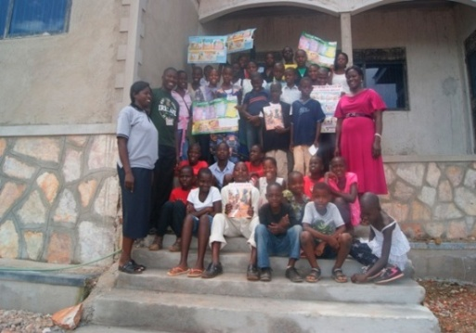
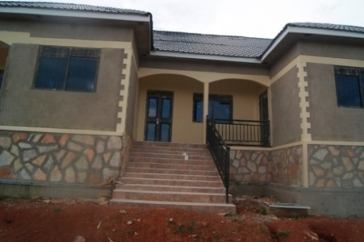
Vision
AHCM envisions an improved quality of life of Vulnerable Children in Uganda with quality Education, proper Accommodation and Health Care living a Godly life.
Mission
AHCM is a committed to meeting the spiritual and physical needs of vulnerable children in Uganda through strategic partnership ministering and
undertaking specialized and sustainable child focused initiatives.
Our Values
- Faith in God
- Respect and Humility
- Honesty and Accountability
- Compassion and Fairness
- Perseverance
- Thankfulness
- Loyalty
- Belongingness
Our children are provided with accommodation, food, clothing, health care and educational opportunities (both vocational and formal school training), and also receive instruction in morals, manners and how to live in our society.
The love and care we provide changes the children’s stories from one hopelessness to hopefulness and gives them the tools they need to not only envision a different future, but to live it. Please join our family and help us achieve our Another Hope.
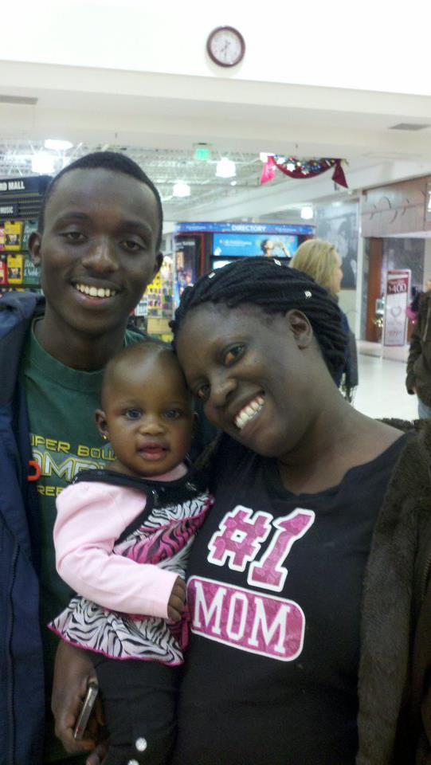
Ms. Ruth Bulyaba, the Founder and Executive Director of Another Hope, received her Diploma in Information Systems Management and her Bachelors and Masters in Statistics. Her husband Mr. Daniel Kasozi has a Bachelors degree in Social Work and Social Administration and he is
Pursuing a Masters in Project Planning and Management. Daniel’s background has helped AHCM to move greater heights.
Daniel and Ruth have so far one biological child. Renee Jayden Nakasiita and still believe God for more children
The Environment
AHCM is located in Wakiso District, in a village of Kkona west II, a few kilometers away from the District Headquarters. We live in an area where open spaces are more common than the heart of the city. The breeze is so great.
Although we are a “Christian home” we provide support to children from all backgrounds and religions. It is estimated at least 20% of the children in Uganda are orphaned and the Wakiso area reflects this statistic. Currently of the 152 children we support some stay with their parents / guardians while others live permanently on the site. Our aim is to expand support for additional vulnerable children throughout the community. We may not be able to help all, but we certainly can make a difference in these children’s lives and invite you to help us by volunteering. 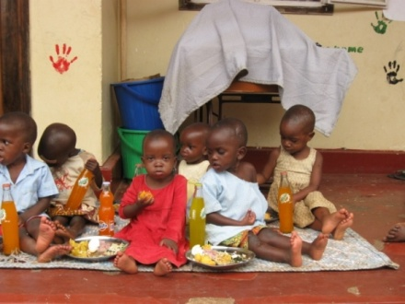

Volunteer Associated volunteer costs
Table1: volunteers costs by item
ITEM | AMOUNT (US $)
Accommodation | 150
Airport pick up & drop (day) | 60
Airport pick up & drop (night) | 100
On-site cooked meals throughout the day including morning tea with a simple food to accompany the porridge or tea, a hearty lunch, and a large supper. Food varies and may include beans, posho (cornmeal), rice, potatoes, meat, fish, nuts, peas, cassava, matooke (a type of banana akin to a potato in taste) and other fruits and vegetables in season. 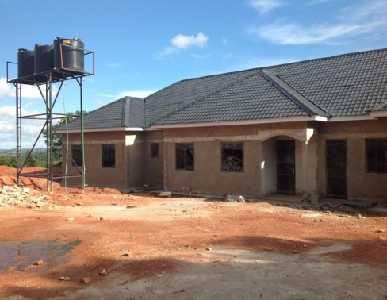
Guest House
A guest house with 6 bedrooms, 2 toilets, 2 bathrooms, kitchen, a dinning and a living room is available at the same premises like the children’s home
It does not have running water all the time. Like most places in Uganda, you will use a basin and jerry can to bathe. In most cases the longer you stay, the less support you will need in learning and operating in our culture, communication in English(the language used in schools) will help us to educate these anxious –to-learn children.
Health
We need people who can assess and provide training and support in basic health care. The support needed varies widely. It may be putting plasters/bandages on scraped knees. Classes on avoiding dehydration or it may be providing monetary support when the children need hospitalization for example. Also Doctors experienced in various fields can be utilized especially in the community health outreaches or health centres
Basic Childcare
From ensuring the little ones have bathed and bushed their teeth to making sure each child has clean clothes, we could use your help. Need people in the area of sports and other recreation

Construction
If you have the construction experience, it will benefit us a lot as we are still involved in construction a lot such as the perimeter wall, permanent office and the vocational school that we plan to do
Fundraising
We need people who can help us fund raise for the children’s welfare, Education, Administration and the different projects that we are running
School fees
School fees are one of our major challenges. We have children from pre-primary to tertiary institutions. We find ourselves that the $25 per month cannot sustain the basic needs of the child and then pay the school fees. Also most of our children are not sponsored. If you can help fundraise towards the school fees this will be highly appreciated. School fees depend on the level of education, type of school and whether a school is in rural or urban settings. There are three school terms in a year and also two semesters in a year
Below is a table showing the school fees range of all Education levels

Table 2: School fees range of Education level
Education level | School fees range (US$)
Pre-Primary | 30-100 per term
Primary | 30-150 per term
Secondary | 250-300 per term
Tertiary | 200-850 per semester

Income generation
We desire to teach our children life skills and self-reliance. We are planning a small poultry and piggery project and we have a guest house project- this is done to help AHCM not to entirely rely on donations.
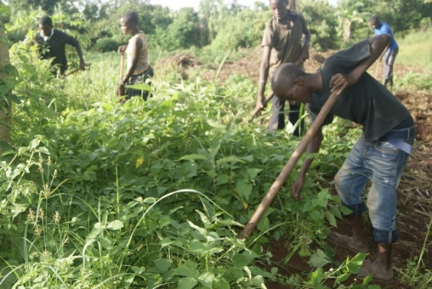

Your Job
Based on your skill set and desires, we welcome you to share your talents and enthusiasm and help us create a bright future for these children.

We need assistance in many areas: childcare, education, health. Developing support programs such as creating income-generating projects or a child-sponsoring program), helping us to develop and manage our Volunteer program, providing activities in music, dance, drama, crafts etc and other areas.

Our children range in age from 0 years to 17years and young adults aged 18-23 years. If you feel you can give positively to the children, we know you can help us.
Preparation
- Pray about it
- Apply for Visa through the Uganda Embassy in your respective country (http://uganda.travisa.com ) for example if in the USA the Ugandan Embassy is in Washington DC
- Make sure passport is current
- Purchase airline tickets to Entebbe
- Go to travel clinic to get shots and medications for malaria prevention
- Collect donations to bring –ask Ruth and Daniel what they need.
- You can contact the airline to see if they could give you an exemption to carry additional luggage.
Things to bring along
- There is a charge of $150/week per volunteer to cover the costs of your stay
- There is also a $60 charge for the airport pickup and drop off, if you travel during day and $100 Airport pickup and drop if you travel at night.
- You should bring cash for these expenses and new $100 dollar bills. You get better exchange rate on large bills and they have to be new or newer.
- There is nothing more fun than bringing gifts for your sponsored kids (if you have any with AHCM) or for other kids over there. Most volunteers find it the best part of the trip to be able to give gifts to the children and see the joy on their faces.
- Bring your camera!!!!!!
- Flashlights and extra batteries (the kids love these, you might want to bring extra to give them. Most nights the electricity goes out!
- Towel and wash cloth, soap, shampoo. You can leave them at AHCM when you are leaving.
- Sunscreen – it may not be needed most days and this also depends on what time of the year you will be there. The sun is hot and it is good to protect yourself.
- Mosquito net – we can pick one up for you here or you can come with one.
- Mirror – You may need to have one if you want to see yourself in the bedroom but the bathroom will contain one.
- We can provide instant coffee and creamer, but you might want to bring your own if this is necessary to you
- Powdered drink mix if you want something other than water
- Women need skirts or dresses when not at AHCM premises. It is also good to dress up in skirts or dresses to show respect if making a home visit. Women can wear capries – not short shorts. Also men can wear shorts.
- You can bring baby wipes along. It is a good way to clean up if can’t get a shower in. You can use these to clean your hands before meals e.t.c
- Hand sanitizer is ver necessary
- Children’s picture books to read to kids
- Kids love pictures. You can bring your ipad and iphone and the kids will love to look at your pictures.
- Bring adaptors for electrical outlets
- You can buy some stuffed animals, because the kids like them but they get very dirty over here.
- Laundry detergent to wash your clothes (can buy laundry soap here too)
- Menstrual pads to donate to the young women

Things you will do
- Help with the children. They love attention, just hugging them, interacting with them. The toddlers do not wear diapers, so be prepared. It is just a fact of life.
- Evening devotions with the kids before meal. You will probably be asked to do this and also Sunday Church. You could be asked to preach a message for the children.
- You can help the kids do their chores, walk for water, laundry, dishes, mopping floors, caring for children, bathing the, getting them dressed-just ask to help and they will be glad to have you help!
- You may be asked to make your home meal for the kids. You might want to think about this ahead of time. It has to be something fairly simple. Also you can bring some bags of candy-skittles, etc. and boy, the kids love this stuff. You may wish you had bought more. They don’t get snacks. No cookies, no candy, no gum. You eat your meals and you will get some fruit that is in the season, but it is not like in your country, they do sell candy etc here, but you may not get to many stores etc. It isn’t your country?

----WE WELCOME YOU-----

